**Insert School Logo**

**Semester Two**

**Examination 2018**

**Question/Answer booklet**

**MATHEMATICS**

**SPECIALIST UNITS 1 & 2**

**Section One:**

**Calculator-free**

|  |
| --- |
| Student Name: _____________________________________ |
| Teacher’s Name: _____________________________________ |
|  |

**Time allowed for this section**

Reading time before commencing work: five minutes

Working time for paper: fifty minutes

**Material required/recommended for this section**

**To be provided by the supervisor**

This Question/Answer booklet

Formula Sheet

**To be provided by the candidate**

Standard items: pens (blue/black preferred), pencils (including coloured), sharpener, correction tape/fluid, erasers, ruler, highlighters

Special Items: nil

**Important note to candidates**

No other items may be taken into the examination room. It is **your** responsibility to ensure that you do not have any unauthorised notes or other items of a non-personal nature in the examination room. If you have any unauthorised material with you, hand it to the supervisor **before** reading any further.

**Structure of this paper**

|  |  |  |  |  |  |
| --- | --- | --- | --- | --- | --- |
|  | Number of questions available | Number of questions to be attempted | Working time (minutes) | Marks available | Percentage of exam |
| **Section One**  **Calculator—free** | **7** | **7** | **50** | **50** | **35** |
| Section Two  Calculator—assumed | 11 | 11 | 100 | 100 | 65 |
|  | | | |  | 100 |

**Instructions to candidates**

1. The rules for the conduct of Western Australian external examinations are detailed in the

*Year 12 Information Handbook 2016.* Sitting this examination implies that you agree to abide by these rules.

1. Answer the questions according to the following instructions.

**Show all your working clearly.** Your working should be in sufficient detail to allow your

answers to be checked readily and for marks to be awarded for reasoning. Incorrect answers given without supporting reasoning cannot be allocated any marks. For any question or part question worth more than two marks, valid working or justification is required to receive full marks. If you repeat an answer to any question, ensure that you cancel the answer you do not wish to have marked.

It is recommended that you **do not use pencil**, except in diagrams.

1. You must be careful to confine your responses to the specific questions asked and to follow any instructions that are specific to a particular question.
2. Spare pages are included at the end of this booklet. They can be used for planning your responses and/or as additional space if required to continue an answer.

* Planning: If you use the spare pages for planning, indicate this clearly at the top of the page.
* Continuing an answer: If you need to use the space to continue an answer, indicate in the original answer space where the answer is continued, i.e. give the page number. Fill in the number of the question that you are continuing to answer at the top of the page.

1. The Formula Sheet is **not** handed in with your Question/Answer Booklet.

# Section One: Calculator–free 35% (50 marks)

This section has **seven (7)** questions. Attempt **all** questions. Write your answers in the spaces provided.

Working time: 50 minutes

**Question 1 (8 marks)**

In each case below write expressions using the notation ${}_{ }^{n}{C_{r}}$ and/or ${}_{ }^{n}{P_{r}}$ as needed. Do NOT evaluate.

(a) Five character passwords are created using the letters of the work QUESTION without repetition of characters. How many different passwords can be created if:

(i) no other restrictions apply? (1 mark)

(ii) it contains 3 vowels and 2 consonants? (2 marks)

(b) Six-digit PIN numbers are created using four digits from the set $\left\{1, 2, 4, 6, 8, 9\right\}$ and two digits from the set $\left\{0, 3, 5, 7, 9\right\}$. How many different PIN numbers can be created if:

(i) repetition of digits is allowed? (1 mark)

(ii) repetition of digits is not allowed? (4 marks)

**Question 2 (7 marks)**

(a) Given that $i^{n}=-i$ determine each of the following:

(i) $i^{n+2}$ (1 mark)

(ii) $i^{2n+1}$ (2 marks)

(b) Rationalise and simplify. (2 marks)

$$\frac{1-i}{i+\frac{2}{i}}$$

(c) Simplify. (2 marks)

$${\left(1+i\right)}^{4}-{\left(1-i\right)}^{4}$$

**Question 3 (5 marks)**

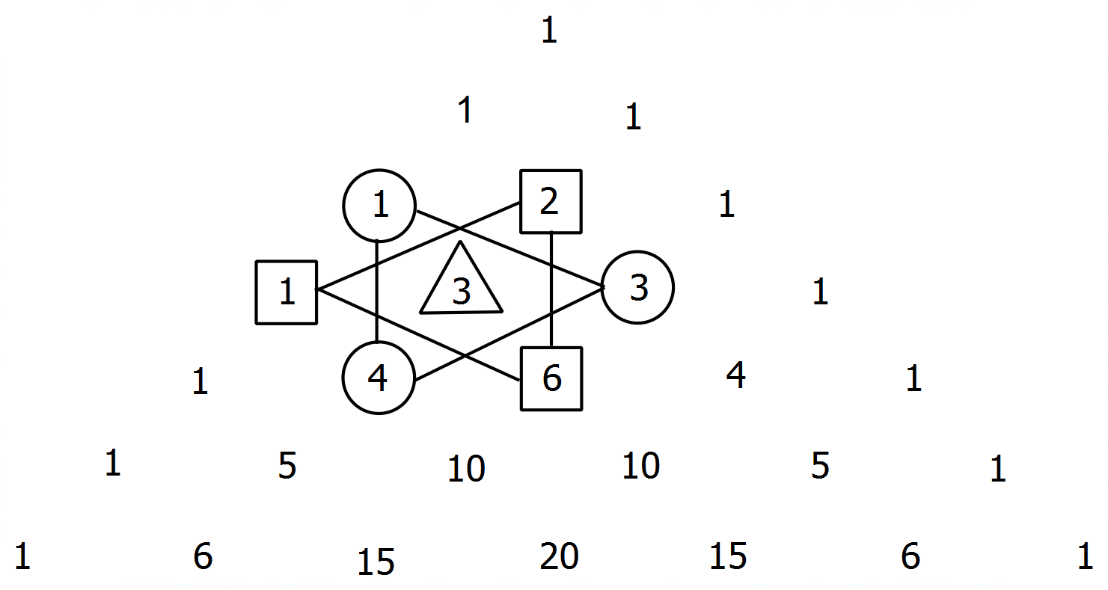In Pascal’s triangle, the cube of a number $n$

can be obtained by adding $n$ to the

multiplication of the numbers around it

as shown.

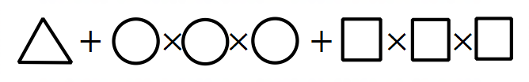

(a) Use the method above to compute $5^{3}$. (1 mark)

(b) Complete the statement below using the notation ${}_{ }^{n}{C_{r}}$. (2 marks)

$5^{3}= 5 + {}_{ }^{4}{C_{0}}×{}_{ }^{6}{C_{1}}×__________$ $+{}_{ }^{5}{C_{0}}×__________×{}_{ }^{6}{C_{2}}$

(c) Create an equation that would give $n^{3}$ using the terms of Pascal’s triangle.

Use the notation ${}_{ }^{n}{C_{r}}$ as needed. (2 marks)

**Question 4 (12 marks)**

(a) Consider the 3x3 matrices $A=\left[\begin{matrix}0 & -1 & 1 \\ 1 & 1 & -1 \\ 1 & 1 & 0\end{matrix}\right]$ and $B=\left[\begin{matrix}1 & 1 & 0 \\ -1 & -1 & 1 \\ 0 & -1 & 1\end{matrix}\right]$.

(i) Obtain the matrix $AB$ and conclude a relationship between $A$ and $B$. (3 marks)

(ii) Using your answers in (i), solve the system of linear equations below. (3 marks)

$$\begin{matrix}-y+z & = & -6 \\ x+y-z & = & 8 \\ x+y & = & 3\end{matrix}$$

**Question 4 (Continued)**

(b) The function $f(x)={\left(x+1\right)}^{2}$ is transformed by $T_{1}=\left[\begin{matrix}-1 & 0 \\ 0 & -1\end{matrix}\right]$ to obtain $f'(x)$, the image of $f(x)$.

(i) Sketch the graph of $f'(x)$ on the axes below and state its equation.

$f(x)$ is shown as a reference. (2 marks)

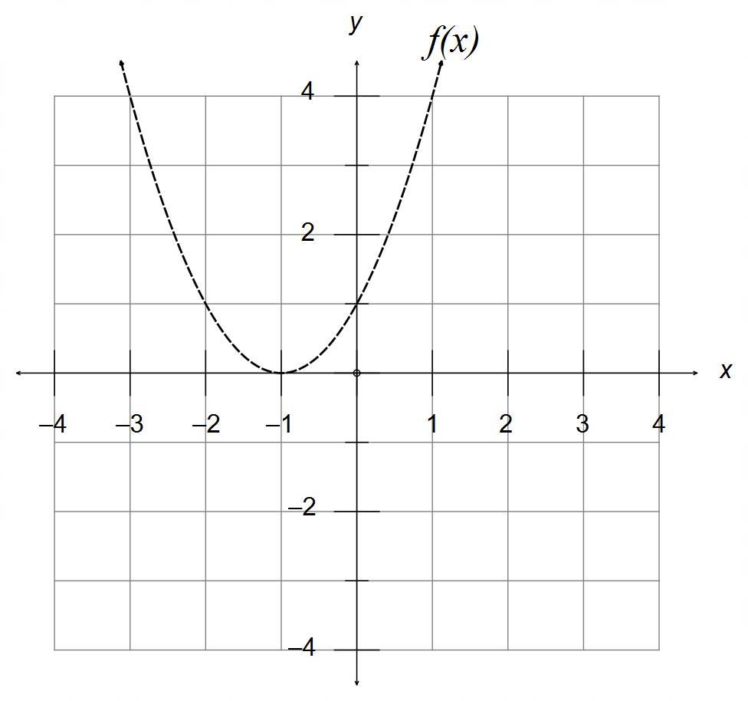

(ii) Transformation matrix $T_{2}$ is then applied to the function $f'(x)$ from (i) and gives the

curve shown below. State the transformation matrix $T_{2}$ and describe its effect. (2 marks)

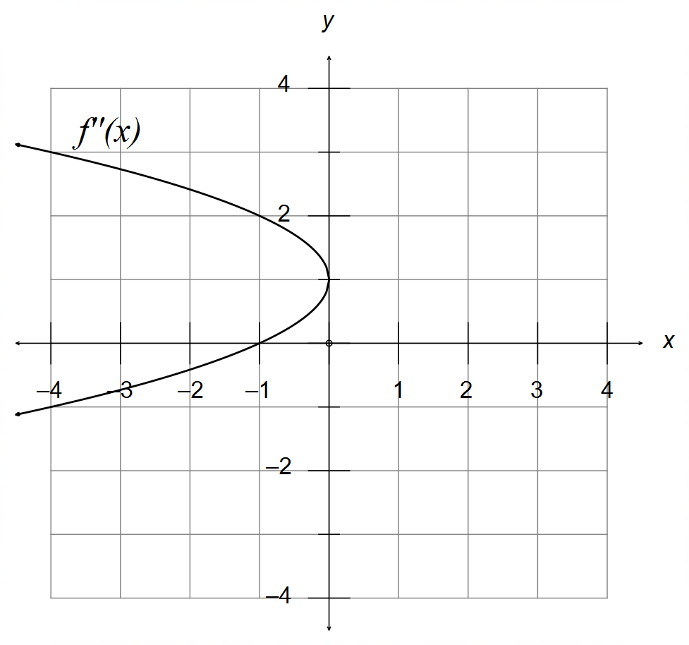

(c) The area enclosed by the function $f(x)$ and the line $y=4$ is units2.

Determine the new area of this region when $f(x)$ is transformed by $T_{3}=\left[\begin{matrix}-3 & 0 \\ 0 & 2\end{matrix}\right]$. (2 marks)

**Question 5 (8 marks)**

(a) The curve below is of the format $y=A\cos\left(ωx+θ\right)$, where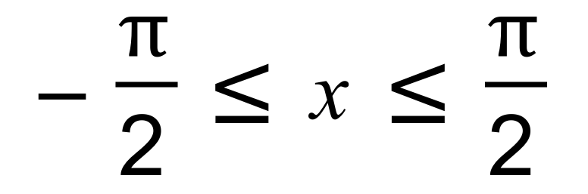 .

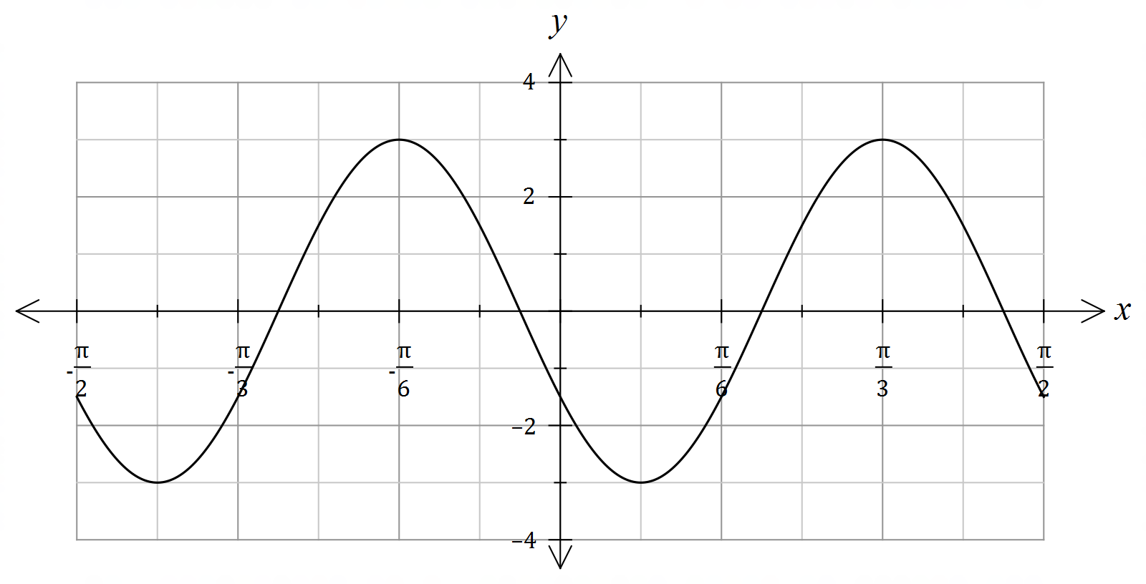

(i) State the value of $A, ω$ and $θ$. (3 marks)

(ii) State the equation of the curve as a sine function with an acute phase shift. (2 marks)

(b) Sketch the graph of $y=2\cot\left(2x-\frac{π}{6}\right)$ on the axes below, where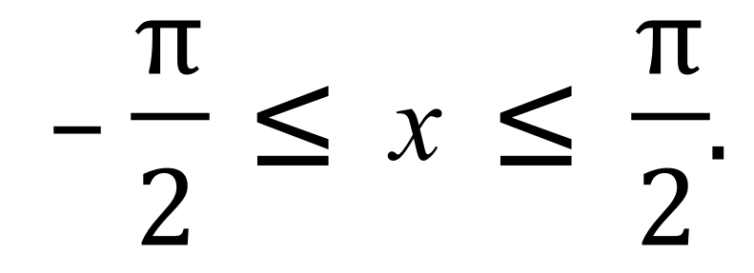 (3 marks)

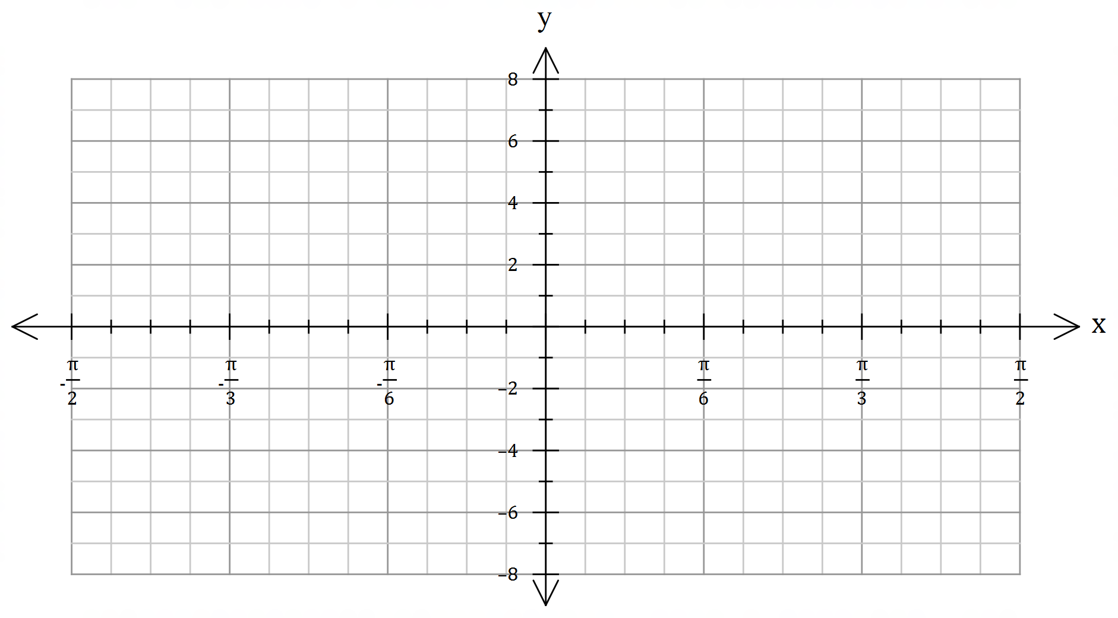

**Question 6 (6 marks)**

(a) Consider the following conjecture: If $a$ is irrational and $b$ is irrational, then $ab$ is irrational.

(i) Provide a counterexample to disprove it. (1 mark)

(ii) State the converse of this conjecture. (1 mark)

(b) Determine whether or not $A⇔B$, by considering the validity of $A⇒B$ and $B⇒A$.

$A:$ The triangle has two equal sides.

$B:$ The triangle has two congruent angles. (2 marks)

(c) Rewrite the following statement using only mathematical symbology notation. (2 marks)

“For all irrational numbers $x$ there exists an irrational number $y$ such that their product is rational”

**Question 7 (4 marks)**

Use proof by contradiction to show that if $n$ is an odd number, then $n^{3}$ is also an odd number.

(4 marks)

**End of Questions**

**Additional working space**

Question number(s): ……………………

**Additional working space**

Question number(s): ……………………